PURCHASE ORDER

Screen Shots

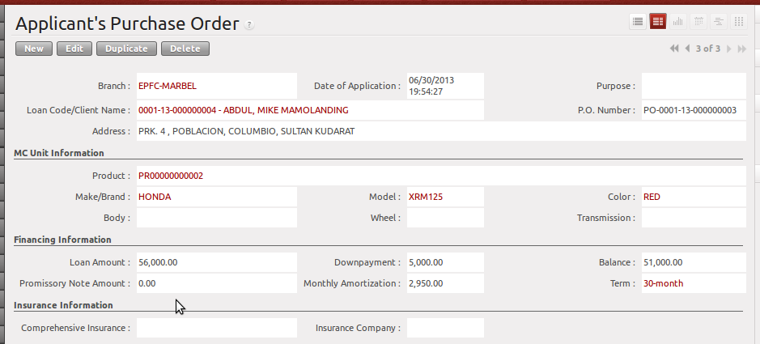
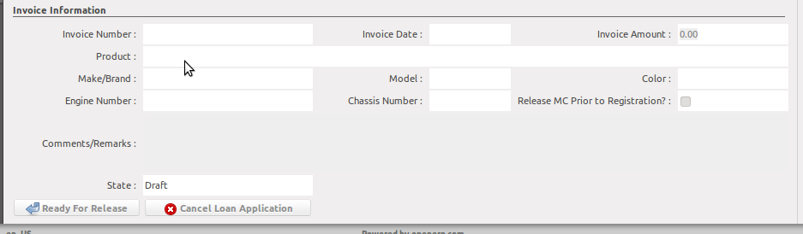
    - Update the purpose field
    - MC Unit Information is from Credit Investigation
    - Print the Purchase Order Slip and transact this to the dealer.

After Dealer's Sales Invoice

After the dealer forwarded the Sales Documents, encode the details of the invoice. Reflect the actual MC Unit by selecting from product list. Triple check the Engine and Chassis Numbers.

Buttons
Ready For Release
If this button is clicked, it will create new record to Loan Release and MC Registration Details.

Cancel Loan Application
Click this when the client opt not to continue the loan application in this stage.

Validations
- You cannot create new record here by clicking the NEW button. The data should come from Loan Approval
- “Ready for Release” button will prompt an error if Invoice Information is not completely filled-up.

